**India’s 2024 Lok Sabha General Election**

* Number of Parliamentary (Lok Sabha) Constituencies in 2024

with tc as

(

select distinct Sname,constituency_id,constituency_Name

from Total_Candidates

)

select COUNT(*) as No_of_constituencies from tc



* State- and UT-Wise Breakdown: Lok Sabha Constituencies

with tc as

(

select distinct Sname,constituency_id,constituency_Name

from Total_Candidates

)

select su.Category,su.Name, COUNT(constituency_Name) as No_of_Consistuencies

from tc

left join state_UTs su

on tc.Sname=su.Code

group by su.Category,su.Name

order by su.Name

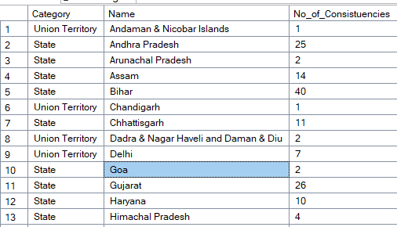

* Major Alliances in 2024 Lok Sabha Election

select Alliance , COUNT(Party_code) as No_of_Parties

from parties

group by Alliance

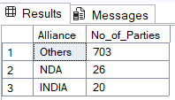

* state- and UT-wise number of candidates who contested the 2024 Indian General (Lok Sabha) Election

select su.Name , COUNT(candidate_name) as No_of_Contested_candidates

from Total_Candidates tc

left join state_UTs su

on tc.Sname=su.Code

group by su.Name

order by su.Name

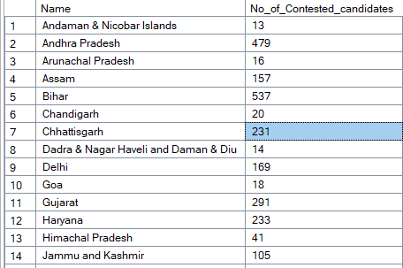

* Alliance -wise candidates contested and seats won in the 2024 Indian General Election, along with winning percentages

with contested_count as

(

select p.Alliance, COUNT(tc.Party) as no_of_candidates

from Total_Candidates tc

left join Parties p

on tc.Party=p.Party_Code

where p.Party_Code is not null

group by p.Alliance

),

winner_sequence as

(

select Sname, Constituency_ID,Party,Total_Votes ,

RANK() over(Partition By Sname, Constituency_ID order by Total_votes desc) as rnk

from Total_Candidates

),

winner as

(

select * from winner_sequence

where rnk=1

),

winner_count as

(

select p.Alliance,COUNT(w.party) as winner_count

from winner w

left join Parties p

on w.Party=p.Party_Code

group by p.Alliance

)

select cc.Alliance,cc.no_of_candidates,wc.winner_count,

concat(ROUND(CAST(wc.winner_count AS DECIMAL(10,2)) / CAST(cc.no_of_candidates AS DECIMAL(10,2))*100, 2),'%') AS win_per

from winner_count wc

left join contested_count cc on wc.Alliance=cc.Alliance

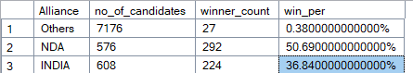

* party -wise candidates contested and seats won in the 2024 Indian General Election, along with winning percentages

with contested as

(

select Party, COUNT(party) as contested_candidates

from Total_Candidates

group by Party

),

ranks as

(

select * ,

RANK() over(Partition By Sname, Constituency_ID

order by Total_votes desc) as rnk

from Total_Candidates

),

winners as

(

select Party, COUNT(Party) as won

from ranks

where rnk=1

group by Party

)

select c.Party, c.contested_candidates,w.won ,

round((CAST(w.won as decimal(10,2)))/CAST(c.contested_candidates as decimal(10,2)) * 100,2) as percentage

from contested c

inner join winners w

on c.Party=w.Party

order by percentage

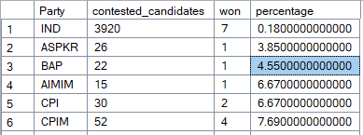

* **party-wise performance within alliances** in the 2024 Indian General (Lok Sabha)

with contested as

(

select Party, COUNT(party) as contested_candidates

from Total_Candidates

group by Party

),

ranks as

(

select * ,

RANK() over(Partition By Sname, Constituency_ID

order by Total_votes desc) as rnk

from Total_Candidates

),

winners as

(

select Party, COUNT(Party) as won from ranks

where rnk=1

group by Party

)

select p.Alliance,c.Party, c.contested_candidates,w.won ,

round((CAST(w.won as decimal(10,2)))/CAST(c.contested_candidates as decimal(10,2)) * 100,2) as percentage

from contested c

inner join winners w

on c.Party=w.Party

inner join Parties p

on c.Party=p.Party_Code

order by p.Alliance

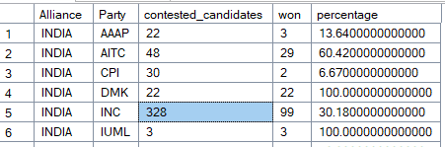

* Top 10 Biggest Victory Margins — NDA Candidates

with contested as

(

select Party, COUNT(party) as contested_candidates

from Total_Candidates

group by Party

),

ranks as

(

select * ,

RANK() over(Partition By Sname, Constituency_ID

order by Total_votes desc) as rnk

from Total_Candidates

)

select Top 10 su.Name, r.Constituency_Name, r.Candidate_name,r.Party,p.Alliance,r.Total_Votes,r.Votes_per

from ranks r

join Parties p

on r.Party=p.Party_Code

join state_UTs su

on r.Sname=su.Code

where rnk=1 and p.Alliance='NDA'

order by Votes_per desc

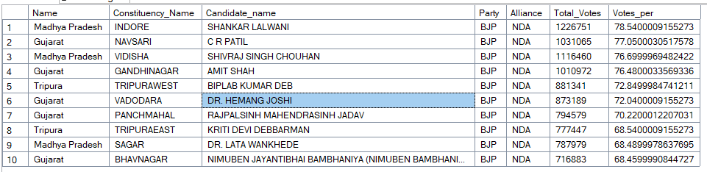

* Top 10 Biggest Victory Margins — INDIA Candidates

with contested as

(

select Party, COUNT(party) as contested_candidates

from Total_Candidates

group by Party

),

ranks as

(

select * ,

RANK() over(Partition By Sname, Constituency_ID

order by Total_votes desc) as rnk

from Total_Candidates

)

select Top 10 su.Name, r.Constituency_Name, r.Candidate_name,r.Party,p.Alliance,r.Total_Votes,r.Votes_per

from ranks r

join Parties p

on r.Party=p.Party_Code

join state_UTs su

on r.Sname=su.Code

where rnk=1 and p.Alliance='INDIA'

order by Votes_per desc

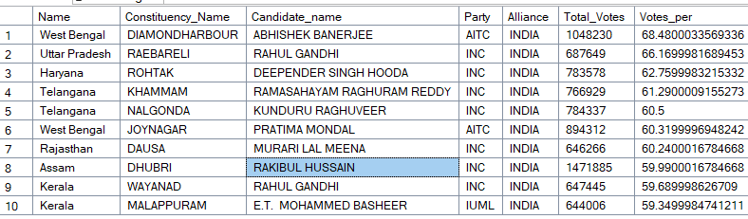

* Top 10 Biggest Victory Margins — Others Candidates excluding Independent

with contested as

(

select Party, COUNT(party) as contested_candidates

from Total_Candidates

group by Party

),

ranks as

(

select * ,

RANK() over(Partition By Sname, Constituency_ID

order by Total_votes desc) as rnk

from Total_Candidates

)

select Top 10 su.Name, r.Constituency_Name, r.Candidate_name,r.Party,p.Alliance,r.Total_Votes,r.Votes_per

from ranks r

join Parties p

on r.Party=p.Party_Code

join state_UTs su

on r.Sname=su.Code

where rnk=1 and p.Alliance='Others' and r.Party not in ('IND')

order by Votes_per desc

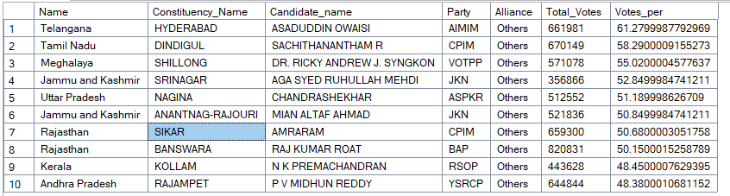

* Top 10 Biggest Victory Margins — Overall

with contested as

(

select Party, COUNT(party) as contested_candidates

from Total_Candidates

group by Party

),

ranks as

(

select * ,

RANK() over(Partition By Sname, Constituency_ID

order by Total_votes desc) as rnk

from Total_Candidates

)

select Top 10 su.Name, r.Constituency_Name, r.Candidate_name,r.Party,p.Alliance,r.Total_Votes,r.Votes_per

from ranks r

join Parties p

on r.Party=p.Party_Code

join state_UTs su

on r.Sname=su.Code

where rnk=1

order by Votes_per desc

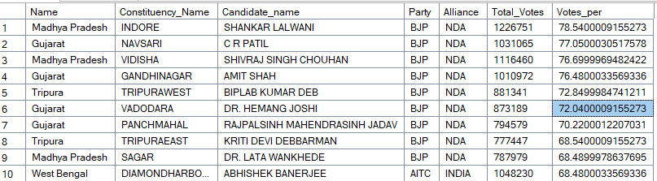

* Independent Candidates winners

with contested as

(

select Party, COUNT(party) as contested_candidates

from Total_Candidates

group by Party

),

ranks as

(

select * ,

RANK() over(Partition By Sname, Constituency_ID

order by Total_votes desc) as rnk

from Total_Candidates

)

select * from ranks

where rnk=1 and Party='IND'

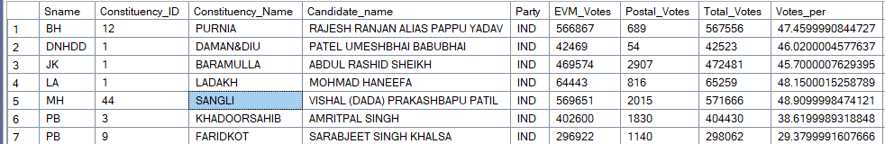

* Difference in total votes in winner and runnerup

with contested as

(

select Party, COUNT(party) as contested_candidates

from Total_Candidates

group by Party

),

ranks as

(

select * ,

RANK() over(Partition By Sname, Constituency_ID

order by Total_votes desc) as rnk

from Total_Candidates

),

won_candidate as

(

select Sname,Constituency_ID,Constituency_Name,Party,Total_Votes

from ranks r

left join state_UTs su

on r.Sname=su.Code

where rnk=1

),

runnerup_candidate as

(

select Sname,Constituency_ID,Constituency_Name,Party,Total_Votes from ranks

where rnk=2

)

select wc.*,rc.party as runner_party,rc.total_votes as runner_votes , wc.Total_Votes-rc.Total_Votes as Vote_difference

from won_candidate wc

join runnerup_candidate rc

on wc.Sname=rc.Sname and wc.Constituency_ID=rc.Constituency_ID

order by wc.Sname , wc.Constituency_ID

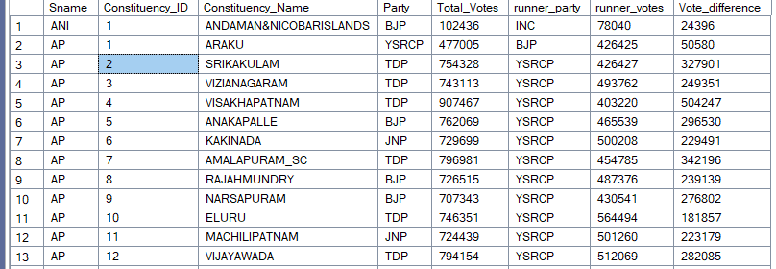

* Statewise – Alliance-wise Seats Won Overview(Pivot Summary)

with contested as

(

select Party, COUNT(party) as contested_candidates

from Total_Candidates

group by Party

),

ranks as

(

select * ,

RANK() over(Partition By Sname, Constituency_ID order by Total_votes desc) as rnk

from Total_Candidates

),

won_candidate as

(

select name as State,Alliance,Total_Votes

from ranks

join state_UTs on Sname=Code

join Parties on Party=Party_Code

where rnk=1

)

select state, [NDA],[INDIA],[Others]

from won_candidate

pivot

(

count(total_votes) for Alliance in ([NDA],[INDIA],[Others])

) as PivotTable

